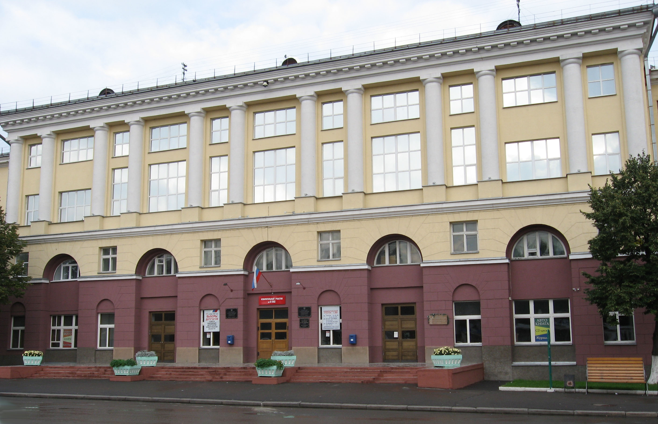

PROGRAMME
The Ist International Innovative Mining Symposium (in memory of Prof. Vladimir Pronoza)

24-26 April, 2017

Russia, Kemerovo - Mezhdurechensk
T.F. Gorbachev Kuzbass State Technical University
FOUNDERS OF THE International Innovative Mining Symposium

T.F. Gorbachev Kuzbass State Technical University
Mezhdurechensk Branch of T.F. Gorbachev Kuzbass State Technical University

PARTNERS OF THE International Innovative Mining Symposium

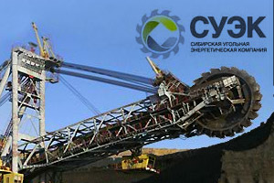 | SUEK JSC  SUEK is one of the world’s largest coal companies and the leading coal producer in Russia. Our competitive strengths include: large, high-quality coal deposits, modern quality-assured washing plants and highly cost-efficient production and distribution.  Our mission is to help fuel the world whilst delivering value to all our stakeholders. We accomplish this by producing coal safely and efficiently and reliably supplying a broad range of coal products to our customers in 37 countries; by building long-term relationships with suppliers and partners, and by developing the skills and competence of all our 32,124 employees.
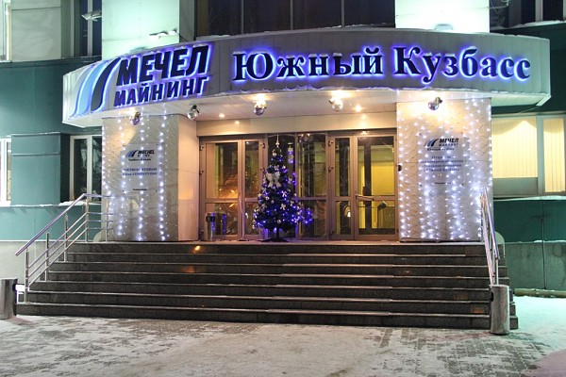 | Southern Kuzbass Coal Company  Southern Kuzbass Coal Company was formed in 1993 as several mining and processing enterprises joined forces.  The company produces coking and steam coals, and comprises enterprises with many years of glorious history, many awards, well-developed infrastructure and highly proficient employees.  Total coal reserves of the company’s mines and open pits are currently estimated at more than 1.7 billion tonnes. Total amount of coal so far mined by the company’s enterprises is approximately 280 million tonnes. Southern Kuzbass Coal Company’s produce is in high demand both in Russia and abroad.  The company undergoes large-scale reconstruction and modernization, implementing superior technologies. Over the years, Southern Kuzbass Coal Company managed to create a united, strong, competitive company which makes a major contribution to the economy of both region and country.

Greetings from Program Committee
Dear participants and guests of the Symposium!
We heartily welcome you to the hospitable Kuznetsk land. We hope that the meeting of scientists from different mining regions of the world will bring mining science to new horizons of innovative development and expand the possibilities of using new high-productive, resource-saving and cost-effective technologies.
Today, the innovative development of the mineral resource sector in industrial regions threw a new challenge to the system of higher mining education. The role of engineering pedagogy is increasing in globalization of mining and engineering humanization.
The purpose of the Ist International Innovative Mining Symposium (in memory of Prof. Vladimir Pronoza) is to create a platform for international discussion of specialists, experts and researchers of mining problems.
We wish all the participants productive and successful cooperation!

Andrey A. Krechetov,
Rector of T.F. Gorbachev Kuzbass State Technical University

Evgeny P. Yutiaev,
General Director of JSC “SUEK-Kuzbass”

Victor N. Slulditsky,
Managing Director of JSC “South Kuzbass”

Tatyana N. Gvozdkova
Director of Mezhdurechensk Branch of T.F. Gorbachev Kuzbass State Technical University

Greetings from Scientific Editors
Dear Authors and Speakers!
On behalf of the scientific editors of the Symposium we would like to welcome you and wish you successful and fruitful work.
The development of mining technologies is impossible without innovation in the whole complex process of extraction of mineral resources, investment modernization of mining equipment and the development of human capital.
Your interest and active support make the Symposium a convenient platform for the exchange of ideas and achievements in their implementation between scientists and specialists.
We hope that interesting discussions and constructive dialogues in the framework of the Symposium and during cultural activities will contribute to the development of scientific areas in the field of mining, will help to strengthen scientific relations and international cooperation.
We wish all participants and guests of the Symposium exciting discussions and debates, meetings and new business contacts, new achievements, success, happiness and prosperity!

Sergey A. Zhironkin, Dr.Sc., Professor

Maxim A. Tyulenev, PhD, Professor

Alexey A. Khoreshok, Dr.Sc., Professor

Svetlana G. Kostyuk, PhD, Vice-Rector for Science and Innovations

Publishing partner of Symposium:

PROGRAM COMMITTEE
Andrey A. Krechetov | Rector of T.F. Gorbachev Kuzbass State Technical University, Kemerovo, Russia
Evgeny P. Yutiaev | General Director of JSC “SUEK-Kuzbass”
Victor N. Skulditsky | Managing Director of JSC “South Kuzbass”
Khoreshok Alexey A. | Dr.Sc., Prof., Director of Mining Institute, T.F. Gorbachev Kuzbass State Technical University, Kemerovo, Russia
Vöth Stefan | Dr.-Ing., Prof., TFH Georg Agricola, Bochum, Germany
Cehlár Michal | PhD, Prof. Ing., Dean of Mining Faculty, Technical University of Kosice, Kosice, Slovak Republic
Yunliang Tan | PhD, Dean of Mining and Safety Engineering College, Shandong University of Science and Technology, Qingdao, China
Aksenov Vladimir V. | Dr.Sc., Prof., Head of Laboratory of Mining Geotechnical Engineering of the Institute of Coal of SB RAS, Kemerovo, Russia
Kretschmann Jurgen | Prof., Director TFH Georg Agricola, Bochum, Germany
Myaskov Alexandr V. | Dr.Sc., Prof., National University of Science and Technology MISiS, Russia
Misnikov Oleg S. | Dr.Sc., Dean, Tver State Technical University, Tver, Russia
Kazanin Oleg I. | Dr.Sc., Dean, Saint Petersburg Mining University, Saint Petersburg, Russia
Maksarov Vyacheslav V. | Dr.Sc., Dean, Saint Petersburg Mining University, Saint Petersburg, Russia
Ligotsky Dmitry N. | PhD, Assoc. Prof., Saint Petersburg Mining University, Saint Petersburg , Russia
Asmelash Abay | PhD, Assoc. Prof., College of Natural and Computational Sciences, Mekelle University, Ethiopia
Seroni Anyona | PhD, Assoc. Prof., Jomo Kenyatta University of Agriculture and Technology, Kenya
Lesin Yury V. | Dr.Sc., Prof., Kuzbass State Technical University, Kemerovo, Russia
Demirel Nuray | PhD, Middle East Technical University, Turkey
Kantovich Leonid I. | Dr.Sc., Head of Mining Machines and Aggregates Department, National University of Science and Technology MISiS, Moscow, Russia
Gasanov Magerram A. | Dr.Sc. in Economics, Prof., National Research Tomsk Polytechnic University, Tomsk, Russia
Barysheva Galina A. | Dr.Sc., Head of Economics Department, National Research Tomsk Polytechnic University, Tomsk, Russia

ORGANIZING COMMITTEE

Gvozdkova Tatyana N. | Chairman, PhD, Director of Mezhdurechensk Branch of T.F. Gorbachev Kuzbass State Technical University, Mezhdurechensk, Russia
Zhironkin Sergey A. | Dr.Sc., Prof., National Research Tomsk Polytechnic University, Tomsk, Russia
Tyulenev Maxim A. | PhD, Prof., T.F. Gorbachev Kuzbass State Technical University, Kemerovo, Russia
Kostyuk Svetlana G. | Vice-Rector, T.F. Gorbachev Kuzbass State Technical University, Kemerovo, Russia
Levitskaya Irina A. | PhD, Assoc. Prof., Mezhdurechensk Branch of T.F. Gorbachev Kuzbass State Technical University, Mezhdurechensk, Russia
Stavinsky Valentin E. | Assoc. Prof., Mezhdurechensk Branch of T.F. Gorbachev Kuzbass State Technical University, Mezhdurechensk, Russia
Znikina Lyudmila S. | Dr.Sc., Prof., T.F. Gorbachev Kuzbass State Technical University, Kemerovo, Russia

The Ist Scientific Practical Conference “International Innovative Mining Symposium (in memory of Prof. Vladimir Pronoza)”

Monday, April 24, 2017
9.00-10.00 | Registration of participants | Office 1232, Summit Hall 28 Vesennyaya st., Kemerovo
10.00-10.11 | The meeting participants with the leadership of T.F. Gorbachev Kuzbass State Technical University and its Mezhdurechensk Branch, Organizing and Program Committee
11.00-13.00 | Opening Ceremony, Plenary Session
13.00-14.00 | Lunch
14.00-18-00 | Sections Work
18-00 | Dinner
Tuesday, April 25, 2017
During all day | Transfer to Mezhdurechensk | Office 307  36 Stroiteley st., Mezhdurechensk
 | Reception participants and meeting with the leadership of Southern Kuzbass Coal Company and Mezhdurechensk Branch T.F. Gorbachev Kuzbass State Technical University
 | Visiting coal mining enterprises of Southern Kuzbass Coal Company
Wednesday, April 26, 2017
During all day | Transfer to Tashtagol | Sheregesh  Green Mountain,  Hotel “Polytech”
 | Visiting Mountain Ski Resort “Sheregesh”
 | Mining seminar in memory of Prof. Vladimir Pronoza
 | Closing Ceremony
Thursday, April 27, 2017
During all day | Transfer to Kemerovo Airport | Kemerovo Airport

The regulations of presentation:

Performances on the plenary session – 10–15 minutes

Performances with reports on the session work – 8–10 minutes

For all questions contact to

Maxim A. Tyulenev +7-923-613-1977

Sergey A. Zhironkin +7-903-984-3801
tma.geolog@kuzstu.ru

Campus map of T.F. Gorbachev Kuzbass State Technical University, Kemerovo

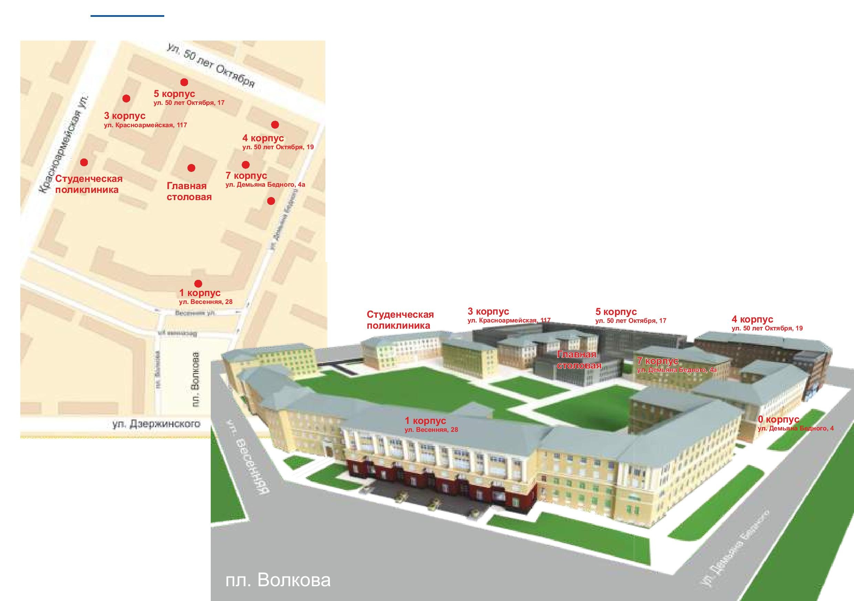

Sheregesh, Green Mountain View

